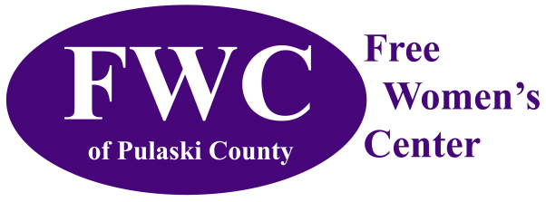
Free Women’s Center of Pulaski County
704 Historic Route 66 West, Suite 106
Waynesville, MO 65584

Board of Directors Candidate Application

Contact Information
Personal
Date
Name
Address
Home Phone
Work Phone
Mobile Phone
Email Address
Employer
Your Title
Address
Phone
Email
Type of Business
Primary service(s)
Area/population served
Please list boards and committees on which you currently serve or have served in the past
(business, civic, community, fraternal, political, professional, recreational, religious, social)
Organization Name |  | Role/Title | Dates of Service
Education/Training/Certificates

Preferred Method of Contact
Work Phone
Residence Phone
Mobile

Are you willing to affirm FWC’s Statement of Faith and Christian Unity?
Yes
No

Can you regularly attend scheduled board meetings and FWC fundraising events?
Yes
No

Which committee would you like to serve as a member?
Personnel
Facilities
Legal
Transportation

What Church Community are you currently a member?

Education / Experience
Finance | Grant Writing
Accounting | Fundraising
Personnel | Outreach
Human Resources | Advocacy
Administration | Program Evaluation
Management | Public Relations
Nonprofit Experience | Communications
Community Service | Special Events
Policy Development | Health Care
Legal Expertise | Facilities Management

What are your views on birth control and abortion? When do you feel that sex is permissible outside of marriage?

What choices do you feel should be available for a woman with an unplanned pregnancy?

Are there any local businesses/organizations to which you could serve as liaison on behalf of FWC?

How do you feel the Free Women’s Center of Pulaski County would benefit from your involvement on the Board?

Person to Notify in Case of Emergency
Name
Street Address
City ST ZIP Code
Home Phone
Work Phone
E-Mail Address

Agreement and Signature

By submitting this application, I affirm that the facts set forth in it are true and complete. I understand that if I am accepted as a volunteer, any false statements, omissions, or other misrepresentations made by me on this application may result in my immediate dismissal.
Name (printed)
Signature
Date

Thank you very much for applying. We appreciate your interest in our organization.

Please, send your completed application to: info@freewomenscenter.com.

