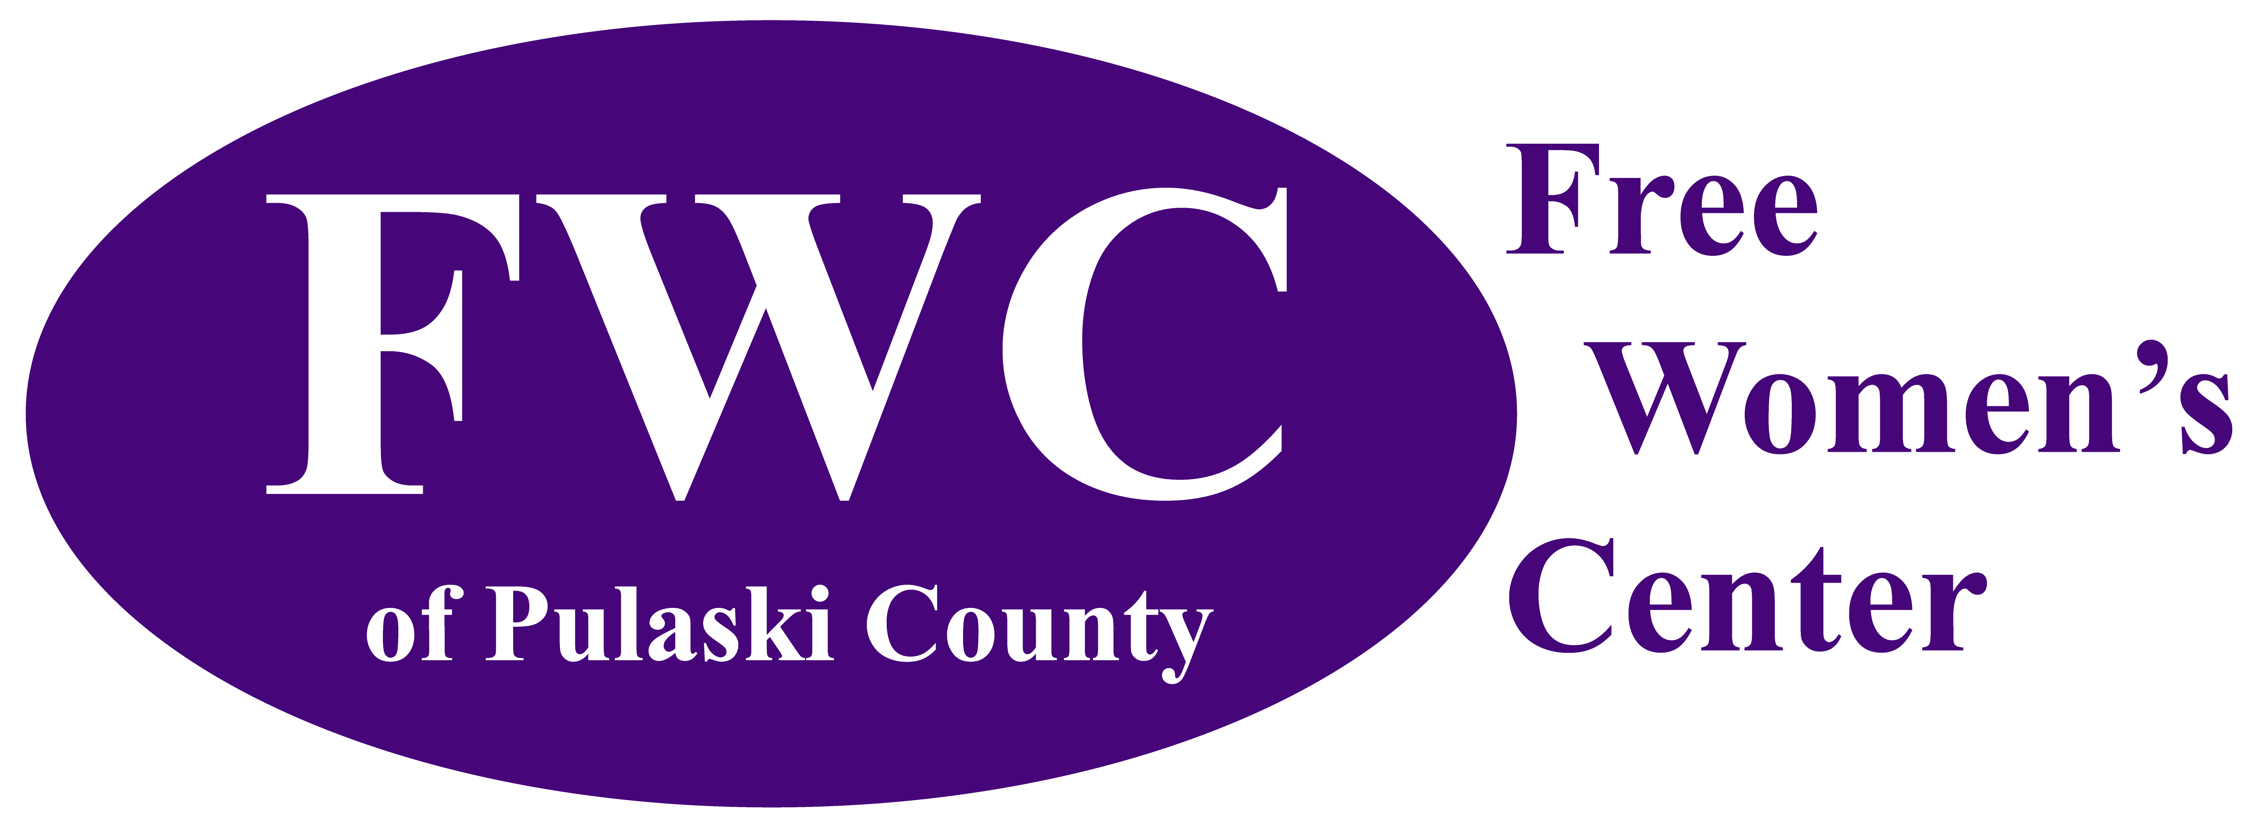
Serving Pulaski and Surrounding Counties
since 2011
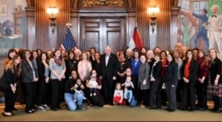
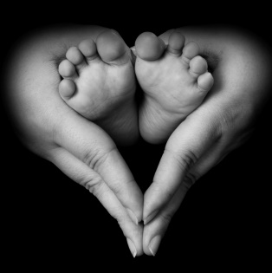
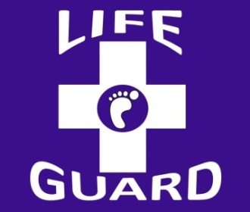
2019 Annual Report
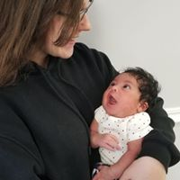
Our Mission
The Free Women’s Center of Pulaski County (FWC) empowers as many individuals as possible to make healthy life choices consistent with the intrinsic value of human life and serves as a leader in the community at large for positive sexual values.

Our Vision
"It is not the will of your Father who is in heaven that one of these little ones should perish." – Matthew 18:14

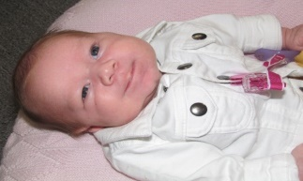
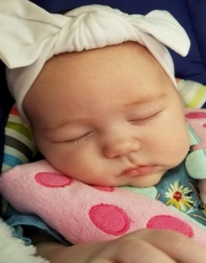
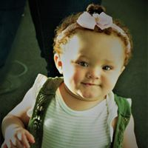
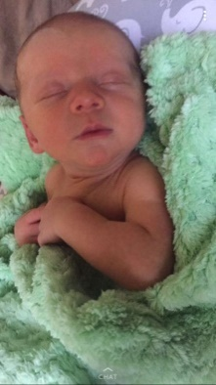

Free & Confidential Services
Pregnancy Testing
Early Diagnostic Ultrasound
Peer Counseling
Prenatal Education
Material & Financial Assistance
Maternity Home Referrals
Adoption Counseling & Referrals
Post-Abortive Counseling
Men’s Mentoring
Sexual Risk Avoidance Education

FWC Services
In 2019, we helped 260 clients and had 229 participating in prenatal/parenting education classes. We performed pregnancy tests on 192 clients, with 150 of them testing positive.
In each case, our goal is to build an honest, candid relationship with each client, ensuring they are valued, that they have options, and that they know we care about them (and their unborn child).

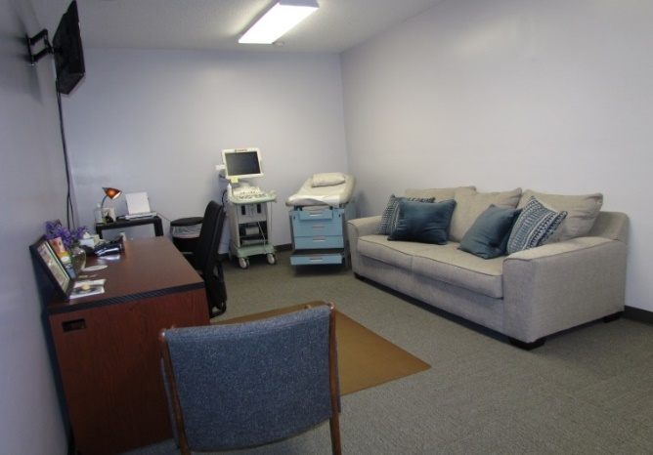
For clients with a positive pregnancy test, we provide up to three ultrasounds until 14 weeks gestation. In 2019, we provided 110 free ultrasounds, compared to 2018 this is a decrease by 35, partly due to loss of volunteer ultrasound techs and we were not able to utilize our mobile unit Daisy.
Through these early diagnostic ultrasounds, we introduce new mothers to their baby. In 2019 we had 58 healthy babies born into this world. This is an increase of 6 babies from 2018, when 52 babies were born. In every case, clients are encouraged to consider God’s plan for their life and their baby’s life.
We’re Mobile!
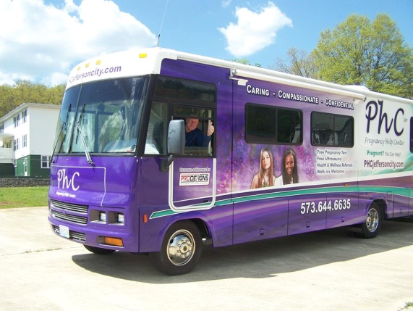
In Pulaski and surrounding counties, multiple contributing factors keep clients from coming through our doors. In order to circumvent these obstacles, we began taking our basic services: pregnancy testing and ultrasounds, to our rural clients. We began renting the Mobile Clinic, “Daisy”, from the Pregnancy Help Center of Central Missouri (Jefferson City) in 2018, offering mobile clinics throughout Pulaski and Phelps Counties one week a month (May – October). In 2019 due to a transition in staffing, Daisy was not utilized; however FWC is on track to utilize Daisy in 2020 beginning in May

2019 Financials
The Free Women’s Center total revenues for 2019 were $176,393. As shown in the graph, our income comes from three fundraising events (Spring Banquet, Fall Walk/Run, and The Baby Bottle Drive), our A2A Grant and general donations. We continue to be blessed as many in-kind donations are received (baby supplies, clothing, furniture, professional services, real estate, etc.) that are not shown in the chart.
As shown on the chart to the left, the Free Women’s Center has been blessed with a steady income trend, thanks to the faithful generosity of our donors. In 2019, we experienced a slight drop in direct appeal (monthly) donations (-6%) and participation at the Run/Walk for Life (-3%); so, the decrease in monthly donors and participation in FWC events had an impact on revenues generated.
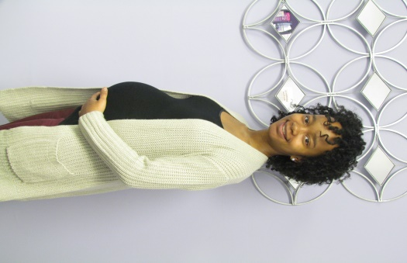
Client Stories
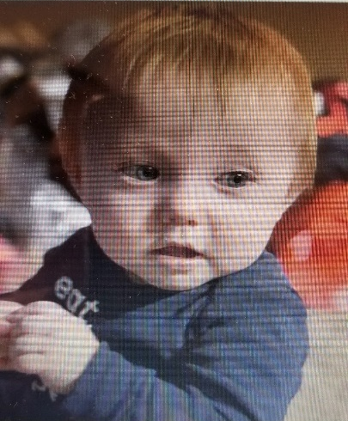
Cyan came to FWC at the end of September 2019. She is a first time mother with few family members in the state of Mo. Cyan is expecting her first daughter in May of this year. Cyan has learned about breast feeding, what to look for in a car seat, how to calm a baby that is crying, etc. Cyan states “FWC has helped me get on my feet, everything is so expensive, and they gave me a fresh start. They have taught me a lot. I really appreciate them.”

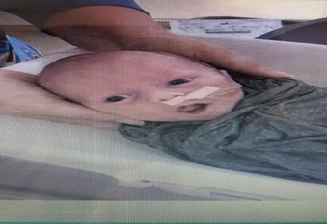
My name is Sheena Hodge. I am a 36 year old recently single mother of 6; 4 daughters and 2 boys. I relocated to Pulaski County in September 2019. I had just come home with a new preemie baby March 1, 2019 and then found out I was expecting another little boy on May 26, 2019. June 11th was one of the hardest, scariest, and saddest days of my life. My husband had been using drugs, and when I came home after work, I was beat. He went to jail and I became a single mother. I then had to stop working due to developing pre-eclampsia. The Lord blessed me with the wonderful people at the free women’s center. They helped me with my rent, gave me diapers, wipes, baby food, and formula when I could not buy it myself. The ladies at the women’s clinic have a way of making you feel like you’re not failing, they just always have such inspiring things to say, uplifting encouragement continuously, and they’re always checking on me!! Thanks to the Women’s Center of Pulaski County I was able to keep my home and take care of my boys who were both born premature. God always provides away and I’ll forever be grateful to the women’s clinic and the wonderful people that work there, they saved my life and gave me hope and now I’m back to work, and I’m paying my bills and I’m doing it on my own again!! I’m going to do everything I can to help the women’s center and other women who are affected by domestic assault!
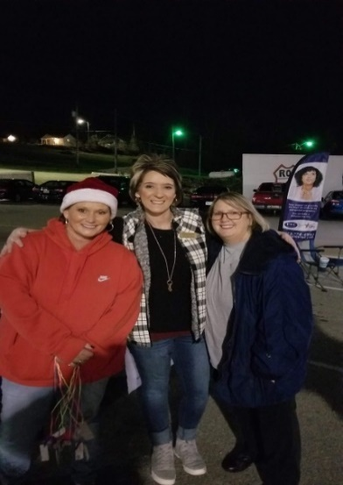
Alternatives to Abortion
The Free Women’s Center participates in Missouri’s A2A Program. The A2A Program helps women carry their unborn child to term instead of having an abortion, and assists them with caring for their child or placing their child for adoption if they choose. Services are available throughout their pregnancy and for one year following birth. Through the A2A Program, the Free Women’s Center helps pregnant women throughout Pulaski County decrease their use of tobacco, alcohol, and illegal drugs and improve their overall nutrition. The program also helps parents provide more responsible and competent care for their children to improve child health and development. By providing support to the parents, we help them develop a vision for their own future. Without guidance and a positive support system, clients become overwhelmed and give up. Our desire is to not only offer help & encouragement from within our program, but to also educate & link clients to other community resources to ensure they create and maintain a safe & loving home for their unborn child and ready to parent.
In 2019, we started providing an invaluable resource to our clients. Through Option Line, women are able to seek free & confidential help outside of normal business hours. FWC provides appointment times every day from 10-11am for women that have made an appointment through the Option Line
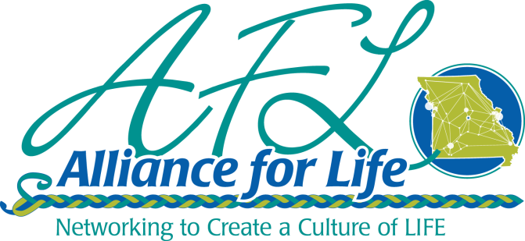
When meeting with our A2A case manager, our clients have the opportunity to set goals and work on everything from job training skills, budgets, childcare, counseling, domestic issues, and college applications. The Alliance for Life oversees the A2A program for the State of Missouri. The Free Women’s Center is a proud affiliate member of this Alliance of pregnancy help centers, maternity homes, and adoption agencies.
Sexual Risk Avoidance Education
In our continuing effort to serve Pulaski County as a leader for positive sexual values, we continue to present Choosing the Best to area 8th Grade Boys and Girls. The course material is delivered over a 10 day period.
Choosing the Best offers a “sexual risk avoidance” approach that promotes sexual delay as the best and healthiest choice for teens, while also teaching about goal-setting, decision-making, healthy relationships, refusal skills, and character building. Choosing the Best educates students about the significant risks associated with teen sex, including pregnancy, STDs, and potential negative emotional consequences. Choosing the Best also emphasizes benefits of waiting, empowering students to make an informed choice about their sexual behavior.
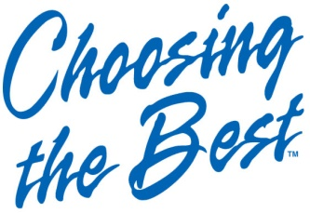
An independent evaluation of Choosing the Best of 7th, 8th and 9th grade students in south metro Atlanta high school and its feeder middle school received either Choosing the Best or the health textbook abstinence education curriculum that complies with state guidelines. The students were administered a 58-item survey prior to the study, immediately after receiving Choosing the Best or the health textbook material, and again twelve months later. 318 students were able to be tracked and matched at the pre-test and 12 month follow-up and had usable sexual activity status data. After one year, results among those students receiving Choosing the Best (treatment group) vs. those receiving the health textbook (comparison group) indicated a: statistically significant decrease in the initiation of teen sex by 47% and statistically significant improvements in five of the six intervening attitudinal variables associated with delaying sexual intercourse. Choosing the Best involves parents. Each evening students must interview and discuss the topics covered that day in school with their parents, obtaining their parents signature on the take home sheet.
The Nativity House
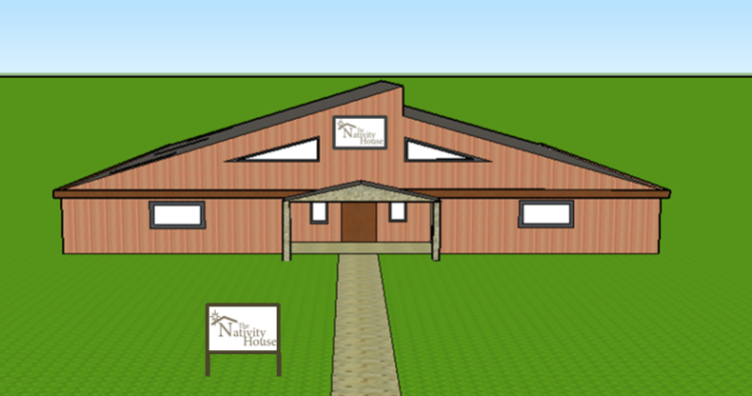
The Nativity House will provide a stable home environment for single, first-time mothers who lack one. Clients can stay throughout their pregnancy and up to their child’s first birthday or 60 days after placing their child for adoption. This project will provide a safe haven, meeting the basic survival and security needs of the most vulnerable pregnant women and their children in our service area. The Nativity House will “close the gap” in our capability to protect vulnerable women in our service area by: Improving pregnancy outcomes; Improving child health and development; and Improving residents’ economic self-sufficiency by helping residents develop a vision for their own future, continuing their education and finding jobs.
In April 2018, we submitted a Neighborhood Assistance Program (NAP) application to the Missouri Department of Economic Development, asking the State to provide 70% income tax credits to businesses who donate the funds needed to construct the finest Maternity Home in Missouri. In December 2018, the Missouri Department of Economic Development awarded the Free Women’s Center $316,485 (in 70% tax credits) as requested. The project period is from 1 January 2019 to 31 December 2020, with a one year extension possible to the end of December 2021. To date, FWC has $274K remaining in 70% tax credits for Missouri businesses.
Ways to Support Our Mission
- Monetary Donations – one-time gifts and monthly pledges at www.supportmyfwc.com
- Attend FWC Fundraising Events
- Donate Material Goods
- Volunteer in the Center
- Become a Church Ambassador
- Become a Board Member
- Shop through Amazon Smile https://smileamazon.com

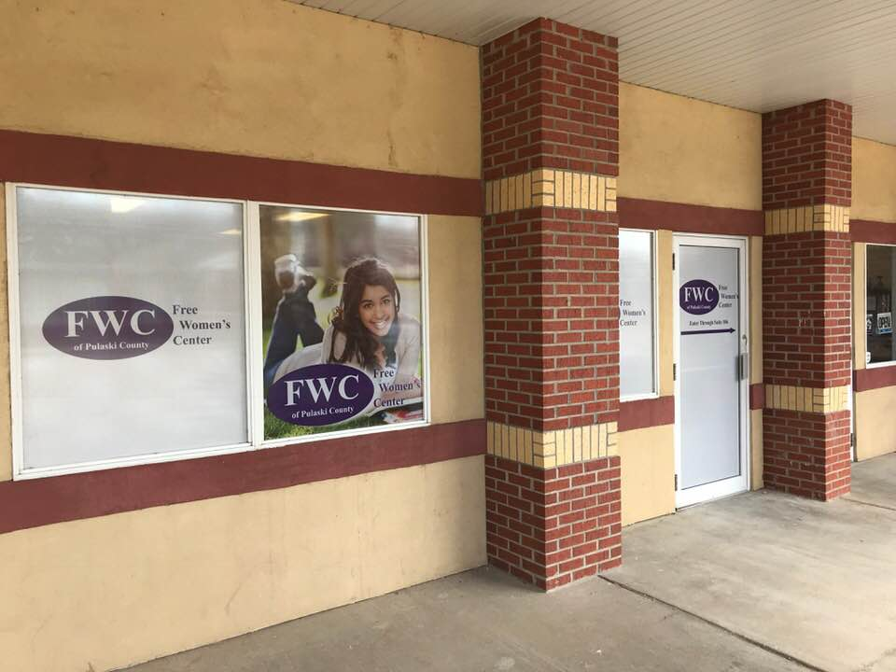
FWC Staff
Adriane Hendrix, Executive Director
Teri Leinbaugh, A2A Case Manager
Katherine Barnett, Client Services Coordinator
Kay York, Ultrasound Technician
Medical Director, Christopher Baldwin

FWC Board
Robert Kirsch, President
Michael Cassidy, Vice-President
John Perling, Secretary
Sherry Campise, Treasurer
Amy Hassett
Jacqueline Loveall
Beatrice Evans
Joseph Bales
Stephanie Stokes
Miki Collier

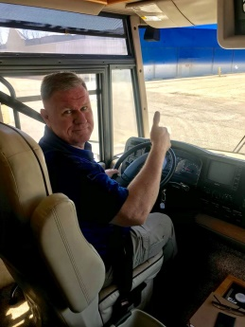
@Free-Womens-Center-of-Pulaski-County
704 Historic 66 West, Suite 106
Waynesville, MO 65583
(573) 774-4992
www.supportmyfwc.com

The Free Women’s Center is affiliated with……..
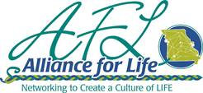
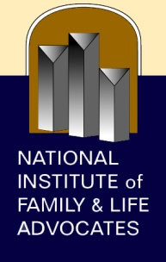
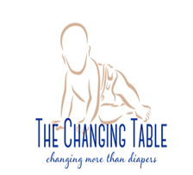
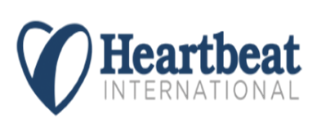
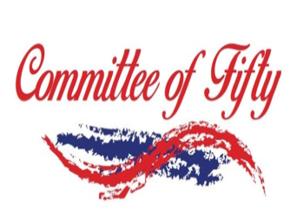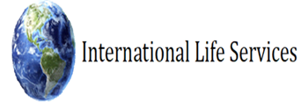

http://choosingthebest.com/research-results

