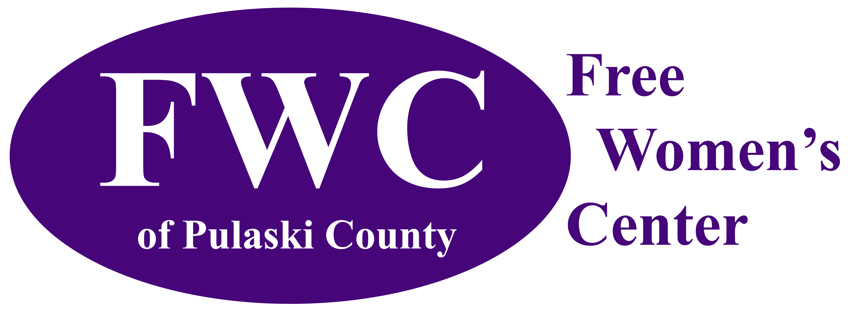
Serving Pulaski and Surrounding Counties
since 2011

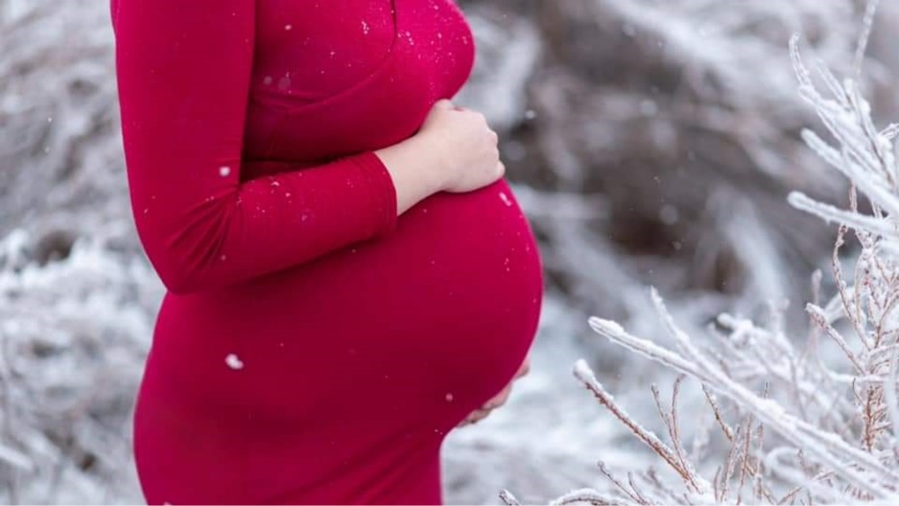

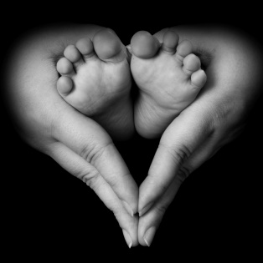
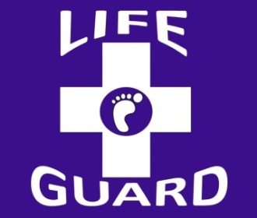
2020 Annual Report
Our Mission
The Free Women’s Center of Pulaski County (FWC) empowers as many individuals as possible to make healthy life choices consistent with the intrinsic value of human life and serves as a leader in the community at large for positive sexual values.

Our Vision
"It is not the will of your Father who is in heaven that one of these little ones should perish." – Matthew 18:14

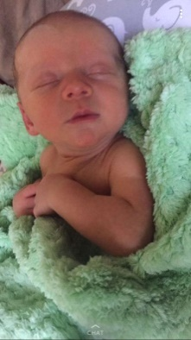
Free & Confidential Services
Pregnancy Testing
Early Diagnostic Ultrasound
Crisis Pregnancy Peer Counseling
Prenatal & Parenting Education
Financial & Material Assistance
Maternity Home Referrals
Adoption Counseling & Referrals
Post-Abortive Counseling
Sexual Risk Avoidance Education

Ways to Support Our Mission

- Monetary Donations – one-time gifts and monthly pledges at www.supportmyfwc.com
- Attend & Participate in FWC Fundraising Events
- Donate Material Goods
- Volunteer in the Center
- Become a Church Ambassador
- Serve with the Board of Directors
- Shop through Amazon Smile https://smileamazon.com
FWC Services & 2020 Financials
Last year over 1,000 individuals walked through the doors of FWC in need of help. 700 individuals were blessed with material supplies. Due to the generosity and continued support from our community members, those in desperate need did not have to go without and were able to keep themselves & their children safe while obtaining the necessary items to meet their basic needs.

- Clothes
- Shoes
- Socks
- Gloves
- Hats
- Coats
- Diapers
- Wipes
- bath/hygiene products
- breast pumps
- blankets
- bibs
- bottles
- pacifiers
- formula
- baby food
- women’s hygiene supplies
- pack-n-play
- changing table
- bassinets/cribs
- swing/bouncer
- car seats

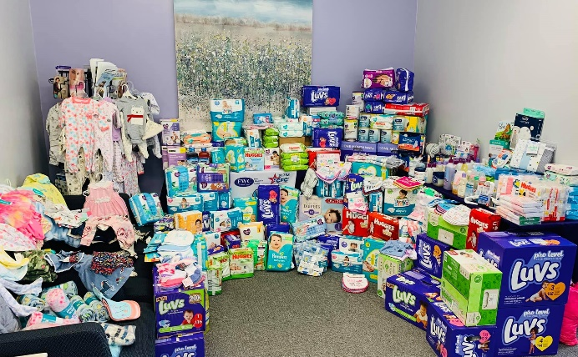
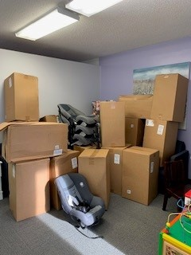

Figure 1: Car seat donation Figure 2: Material Donations

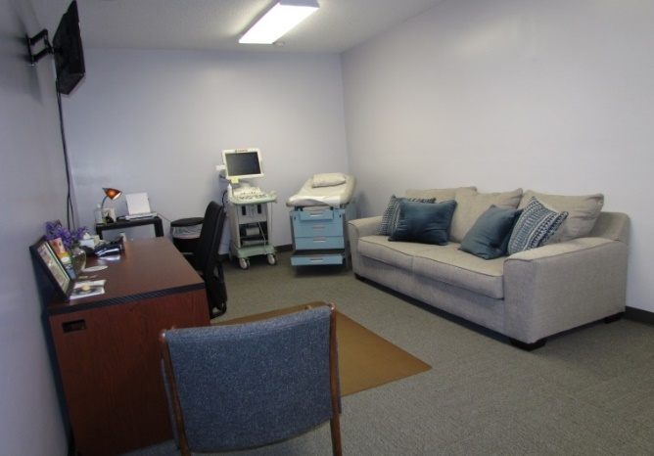
We performed 127 pregnancy tests with 111 having a positive result. When receiving a positive test result, women are then educated on their pregnancy options and provided up to three ultrasounds until the gestation age of 14 weeks. Last year, 84 free ultrasounds were performed on pregnant women ranging in age from 14 to 30+.
FWC provided services to pregnant women and their families not only in Pulaski County, but also in the surrounding counties such as: Phelps, Laclede, Maries, Texas, Camden, and Green. 205 pregnant women enrolled into the A2A program & invited FWC staff to be a part of their pregnancy journey. Overall, 246 females participated in prenatal/parenting education classes.

We have made it part of our mission at FWC to engage and encourage the father of the baby to take on an active role in the pregnancy and beyond. Out of the 205 pregnant women enrolled in the A2A program, 116 fathers participated in case management and/or prenatal education courses last year.

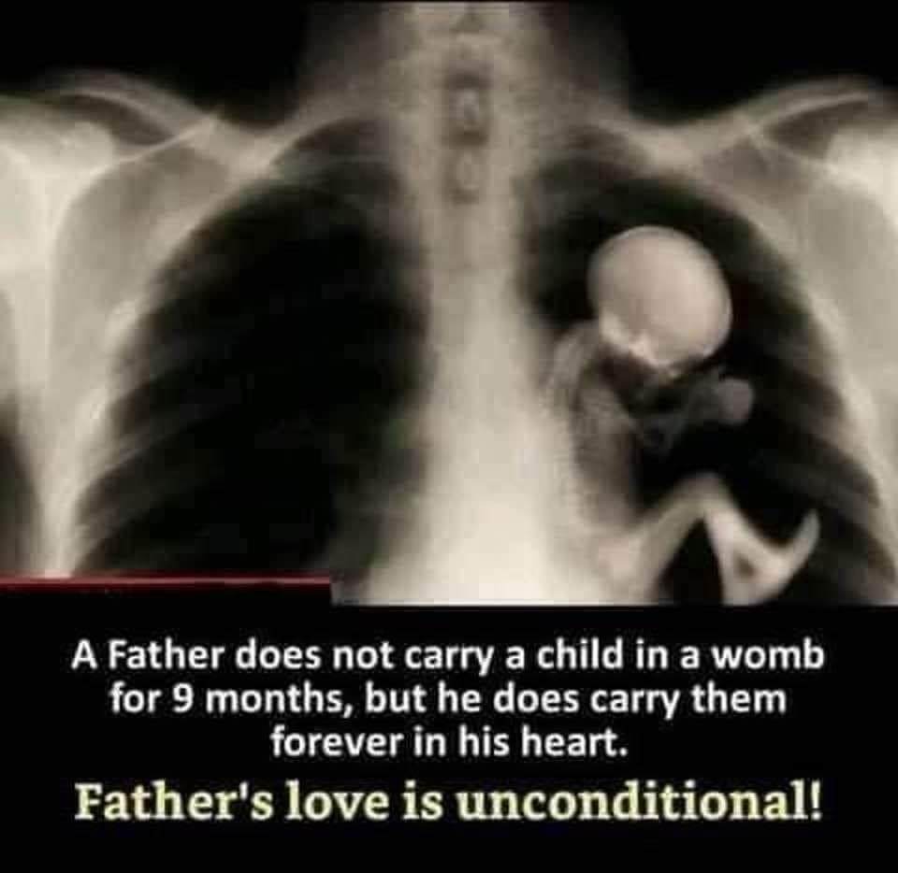

Just in the last year, 21 clients were considered either abortion minded or abortion vulnerable. 5 clients changed their mind, 1 did not. We are happy to report 57 healthy babies were born.

The Free Women’s Center is an independent 501(c)3 non-for-profit organization that is able to provide a variety of services for free due to Partners in Life, three yearly fundraising events (Spring Banquet for Life, The Baby Bottle Drive and The Fall 5K Run/Walk), and the A2A program. Many non-for-profit organizations were heavily impacted by the pandemic including us, however, we remained open and continued to provide services. Education courses went from in person to virtual and curb side and/or delivery service was created for material donations. The total revenue for 2020 was down last year, at $186,000, but God still provided. Through the generous donations received, we were able to update and remodel our front office with the help of Mr. JJ Stokes.

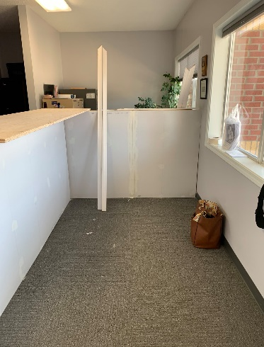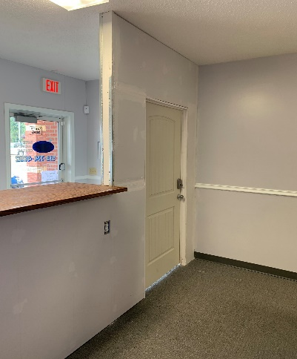

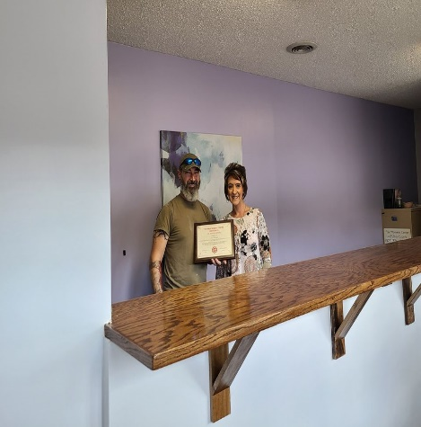

Alternatives to Abortion
The Free Women’s Center is proud to be affiliated with Alliance for Life, an agency that connects pregnancy help centers, maternity homes, adoption agencies, and post-abortion recovery organizations. Through Alliance for Life, FWC participates in Missouri’s Alternatives 2 Abortion Program.

The A2A Program helps women carry their unborn child to term instead of having an abortion and assists them with caring for their child or placing their child for adoption if they choose. Services are available throughout their pregnancy and for one year following birth.

Through the A2A Program, the Free Women’s Center can help pregnant women & their families in a variety of ways: food, clothing, baby supplies, pre-natal/ parenting education classes & skills, childcare, housing-utility-transportation assistance, educational services such as tuition/books, job training & placement, and even domestic violence protection. By providing love & support to the parents, we help them develop a vision for their own future. Without the right tools and a positive support system, clients become overwhelmed and consider giving up. Our desire is to not only offer help & encouragement from within our program, but to also educate & link clients to other community resources to ensure they create and maintain a safe & loving home for their unborn child. Together we can eliminate the crisis, not the pregnancy!
Client Story
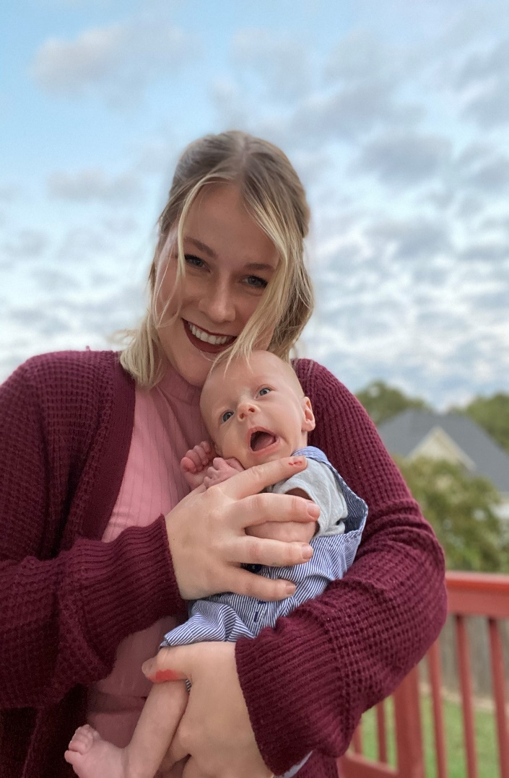
I went into the Free Women’s Center in January of 2020 with the thought of “I need to get rid of this baby”. I was young, was about to get married, I had not graduated college yet and I did not think I was fit to be a mother. A few months passed and I was routinely seeing Adriane and Kat to check up on my progress and check out how I was doing. I was still considering abortion throughout that time but decided to continue with the pregnancy. I started to feel my baby kick during those months, and I thought it was so odd that I was growing a baby inside me.
September 30th was my due date, but I went into preterm labor due to a placenta rupture and my boy was born September 6th. While I was being rushed to the OR for an emergency cesarean, I was told I might lose the baby and that was the scariest thing I had ever heard. I had been baking this boy for 8 months! I could not bear the thought of losing him.
Throughout the third trimester of the pregnancy, I started to get more and more excited to meet him and get ready for him. My husband and I moved, bought a house, and set up the nursery and the next weekend Michael was born. When I woke up from anesthesia the next day, I was able to go to the NICU to see him and once I held him, I had such an overwhelming feeling of love that I could not even bear the thought that I wanted to terminate him months before. They tell you pregnancy gets better, and it is the most beautiful thing a woman can do; but it is not. It is painful and uncomfortable, and you feel sick constantly; but the minute you hold and see your baby it makes you forget everything about pregnancy and makes you want to do it all over again just to have that feeling of seeing your child that you made. I am so glad that I held in there and continued with my pregnancy. I am loving being a mother to a beautiful boy.

Client Story

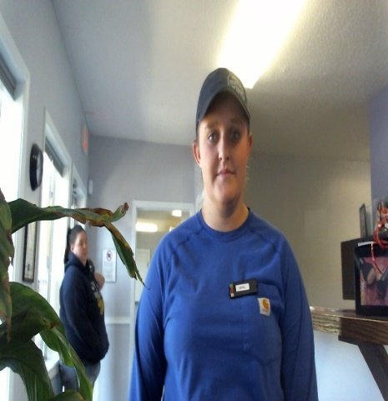
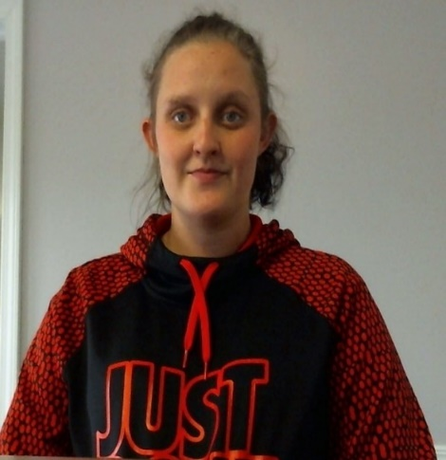
I was in one of the deepest holes of my life. I was using meth, just lost my daughter to the state and was pregnant with my son. I was living anywhere someone would let me for short amounts of time. I thought it was over for me.
About 6 months into my pregnancy, I moved in with my sister and started searching for help. When I found the free women’s center, they offered parenting classes, someone to talk to, care, support, and supplies, and the list goes on and on. It did not take me long to get sober and stay sober. These women helped to build a better woman and a better mother to my children! I am now 1 week away from being sober for 1 year and my kids will be with a mother they can be proud of now. A lot of this I have to thank them for. I have built a love and family with these women and I just could not have done this without their help!

The Nativity House

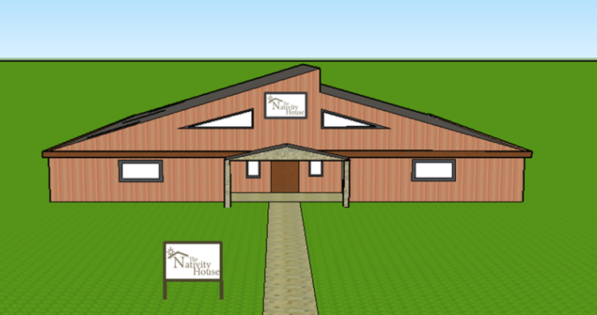
The Nativity House will provide a stable home environment for single, first-time mothers who lack one. Clients can stay throughout their pregnancy and up to their child’s first birthday or 60 days after placing their child for adoption.
This project will provide a safe haven, meeting the basic survival and security needs of the most vulnerable pregnant women and their children in our service area. The Nativity House will “close the gap” in our capability to protect vulnerable women in our service area by: Improving pregnancy outcomes; Improving child health and development; and Improving residents’ economic self-sufficiency by helping residents develop a vision for their own future, continuing their education and finding jobs.

In April 2018, we submitted a Neighborhood Assistance Program (NAP) application to the Missouri Department of Economic Development, asking the State to provide 70% income tax credits to businesses who donate the funds needed to construct the finest Maternity Home in Missouri. In December 2018, the Missouri Department of Economic Development awarded the Free Women’s Center $316,485 (in 70% tax credits) as requested. The original project period was from 1 January 2019 to 31 December 2020, but due to COVID-19 impacting donations, FWC applied for a 1-year extension and was approved. To date, FWC has $228K remaining in 70% tax credits for Missouri businesses.

The Free Women’s Center is affiliated with…..

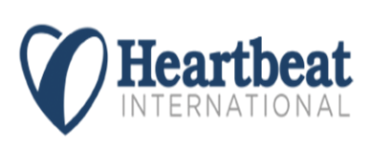
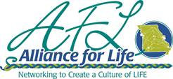
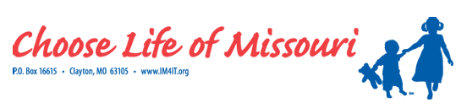

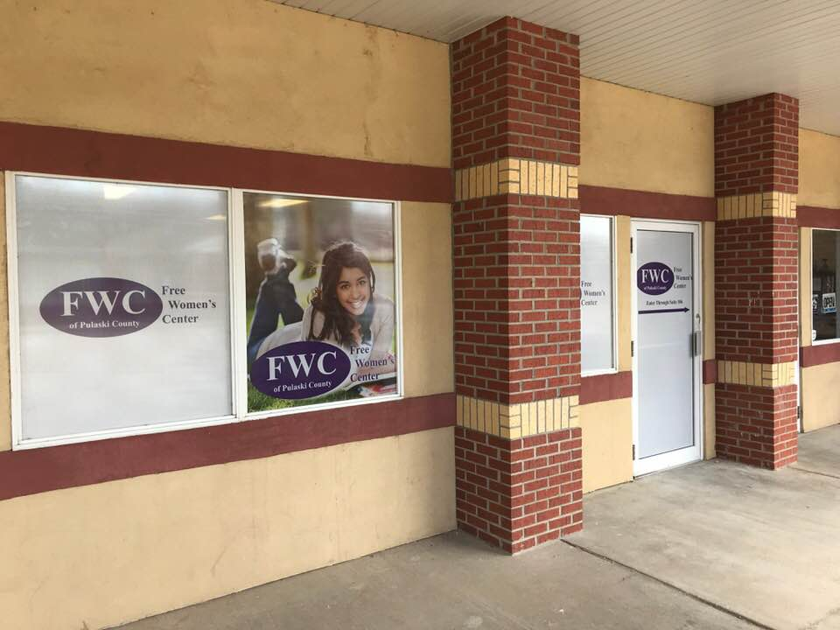
FWC Staff
Adriane Hendrix, Executive Director
Katherine Barnett, Client Services Coordinator & A2A Case Manager
Elizabeth Gann, Client Service Assistant
Kay York, Ultrasound Technician
Robert G Fowers II, Medical Director

FWC Board
Pastor John Perling, President
Michael Cassidy, Vice-President
Sherry Campise Secretary
Jacqueline Loveall, Treasurer
Beatrice Evans
Joseph Bales
Tracy Storie
Kathryn Davis
Robert Kirsch

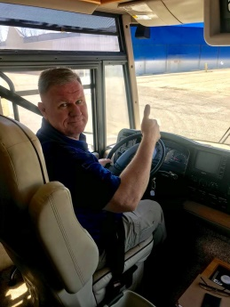

FWC Volunteers: Claudia Gormley & Marcia Gladden

